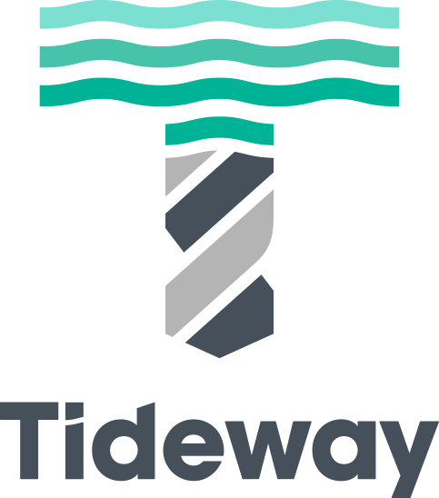
Tideway - Transformational Health and Safety Group
Piling & Diaphragm Walling Sub Working Group
Terms of Reference
Objectives | Inputs | Core Attendees
- To drive improvements in the standard of health and safety in the UK geotechnical industry, adopting Tideway’s Transformational approach to Health and Safety.  - To develop, and adopt across the Tideway Alliance, a series of key initiatives that will improve Health and Safety in the piling (bored & sheet piling), grouting and diaphragm walling environment.  - To foster a common and consistent approach to working practices.  - To share best practices, building from the significant and varied experience of the group and involving where relevant the Federation of Piling Specialists.  - To share lessons learnt between the Tideway Alliance.  - To act as a link between the Tideway Alliance and the wider geotechnical industry, including the FPS.  - To act as a unified voice in liaison with Tideway to agree how piling/dwalling related project-wide initiatives and requirements are implemented. | - Regular meetings, with a targeted agenda  - Papers and proposals drafted by the group for discussion and adoption  - Lessons learnt papers  - Feedback from other industry groups  - External safety alerts | Tideway Nick Butler NB  Tideway Harriet Cheaney HC  ??? Pawel Czajkowski PC  FLo Ponciano Perez PP  FLo Rob Jackson RJ  FLo  FLo  BMB Andy French AF  BMB  BMB  CVB Martin Stanley MS  CVB Phil Risbridger PR  CVB Mark Lynch ML  ??? Charles Lafe  Chair Martin Stanley MS
 | Outputs
- Meeting actions
- Agreed initiatives to be adopted by the Alliance
- Safety alerts / lessons learnt documents/guidelines to circulate within Alliance and to the wider industry
- Changes in working methods or safety provisions
- Standardised approach to a few key aspects of the construction process to manage H&S
Critical Success Factors |  | Optional Attendees
- Attendance, buy-in and collaboration from the Core Attendees and the support of their organisations.  - Structured approach, where agenda items are chosen to reflect the status and current risk profile of the project.  - Honest debate which confronts the root causes of poor Health and Safety.  - Selection and adoption of simple and effective initiatives which tackle major areas of risk.  - Not to waste time on ideas which have limited impact  - Positive attitude from those asked to assist the group (suppliers, operatives & frontline supervisors, parent companies, the wider project etc.) |  | Tideway Stuart Pollard SP
 |  | Frequency
 |  | Every 4-6 weeks
 |  | Distribution
 |  | Attendees; plus apologies

