

Federation of Piling Specialists

Best Practice Guidance

Pumping Concrete to Form Piles

Edition 1: February 2016
DISCLAIMER

The information contained in these Best Practice Guidance Notes has been compiled by the Federation of Piling Specialists and is supplied to the recipient on the following terms:

- The Federation of Piling Specialists, its employees, authors or compilers of these Best Practice Guidance Notes are not responsible for the results of any actions taken on the basis of the information contained in these Best Practice Guidance Notes, nor for any errors or omissions contained in these Best Practice Guidance Notes.

- The Federation of Piling Specialists, its employees, authors or compilers of these Best Practice Guidance Notes, in providing these Best Practice Guidance Notes are not engaged in rendering professional services.

- The Federation of Piling Specialists, its employees, authors or compilers of these Best Practice Guidance Notes shall not be liable to the recipient of these Best Practice Guidance Notes in respect of anything and the consequence of anything done or omitted by the recipient of these Best Practice Guidance Notes in reliance, whether whole or in part, on information contained in these Best Practice Guidance Notes. The recipient acknowledges that, if expert assistance is required, the services of a competent professional person will be sought.

In this document reference is made to various National Regulations, European and British Standards and other appropriate reference documents. Some of the major aspects of these have been summarised. This is done only to assist users of these Best Practice Guidance Notes by drawing their attention to these regulations and standards. It is the responsibility of those who use these Best Practice Guidance Notes to make themselves thoroughly conversant with all the appropriate legislation and standards and not to rely on any reference or summary contained in this document which may be incomplete or not comprehensive. It is not intended that this document should replace any Acts, Codes of Practice, Regulations or other documents having legal or contractual standing.

Of necessity this document addresses the broad principles that should be adopted. Advice in respect of specific equipment or operations should be obtained from the appropriate body or technical reference source.

The recognition of the various and individual responsibilities of “DUTY OF CARE” are fundamental to the application of these Best Practice Guidance Notes and the principle of “Identify the Hazard, Assess the Risk and Take the Appropriate Corrective Action” should always be applied.

Best Practice Guidance

Pumping Concrete to Form Piles

INDEX Page
1 Introduction and Scope 4
2 Selection of Personnel 4
3 Components of a Concrete Pumping System 4
4 Planning and Management of the Concrete Pumping Process 7
5 Maintenance 9

APPENDIX
A Legislation and Standards 11
- Introduction and Scope
This Federation of Piling Specialist best practice guidance has been prepared to supplement the Construction Plant-hire Association (CPA) Good Practice Guide ‘Safe Use of Concrete Pumps’ (September 2013) and provides sector specific guidance.

This document should be used in conjunction with the relevant legislation and guidance listed at Appendix A to ensure the safe pumping of concrete to form piles. This document provides guidance associated with pumping concrete from the concrete pump to the point of discharge into the pile. This document also provides guidance on the maintenance of; plant and equipment, the concrete pipeline, cleaning the pipeline, dealing with blockages within the pipeline and arrangements for wash out water.

- Selection of Personnel
The safe operation of plant and equipment used in a concrete pumping system relies heavily on suitably competent personnel to carry out the required duties. Other site personnel involved in associated activities must also be suitably competent to carry out their duties.

The Pump Operator will hold the CPCS category for a relevant type of pump being used. This category will be supplemented by type specific training for the concrete pump and concrete agitator.

The Rig Operator will hold the CPCS category for a relevant type of rig being used.
Periodic assessments of all those involved with the process should be carried out by a competent person to verify the continuation of safe standards and to assess any further training needs.

Where required, additional familiarisation training should be carried out whenever an operator is transferred to a different make or model of plant or equipment.

- Components of a Concrete Pumping System
 | It is important to evaluate the components of the concrete pumping system to ensure the maximum pressure developed by the pump does not exceed the working pressure of the concrete hose, its couplings and connections.

Figure 1 shows the typical components of a concrete pumping system which consists of:

Concrete Pump
Has a typical maximum Pressure of 70 to 100 bar.

Concrete Agitator
Generally used to ensure continuity of concrete supply.

Pipelines:
Typically used on both the ground and at fixed locations on the rig. Pipelines can be constructed of:
- Steel, which is available in a variety of lengths that usually has a wall thickness of 4mm or 6mm.
- Reinforced rubber hose, which is available in a variety of lengths and usually 100mm or 125mm in diameter.

The bend radius limit on reinforced rubber hose typically is:
- For 100mm hose the radius must not be less than 550mm.
- For 125mm hose the radius must not be less than 700mm.

Note: This should be clarified with the supplier of each contractor’s hose

Consideration must be given to the transporting and handling of hoses (both on site and in equipment yards) to ensure that minimum bend radii are not compromised.

Consideration should be made to shroud the loop hoses on the rig and the hoses that connect directly to both the concrete pump and to the rear of the rig.

Note: Failure of reinforced rubber hose is often as a result of the hose being forced into too tight a radius.

Pipeline Couplings
There are various types of couplings available but more common couplings are either bolted or snap - quick release couplings, which must be fitted with a securing spilt pin. Each coupling should be fitted with a rubber seal.

The following couplings must have a safety sling (Whip-check) incorporated to independently connect the pipeline to either the rig or the pump:
- All couplings on the loop hoses on the rig.
- The hose connection from the rig to the ground pipeline.
- The connection from the ground pipeline to the concrete pump.

Consideration may also be given to fitting a safety sling (Whip-check) to all ground pipeline couplings.

The safety sling (Whip-check) will also act to restrain and secure the connection should the coupling fail.

Concrete Delivery System on the Rig
To allow the auger to move up and down the mast during pile formation, the rig is fitted with a number of components that form the concrete delivery system, these include:
- Steel/Reinforced rubber pipeline that runs along the side of the rig and up the mast.
- Reinforced rubber loop hose connecting the steel pipeline, elbow, swan neck and concrete swivel.
- 180⁰ elbow which conveys the concrete from the steel pipeline running up the mast to the loop hose that connects to the swan neck and concrete swivel.
- Swan neck and concrete swivel allows movement of the auger during the pumping process.

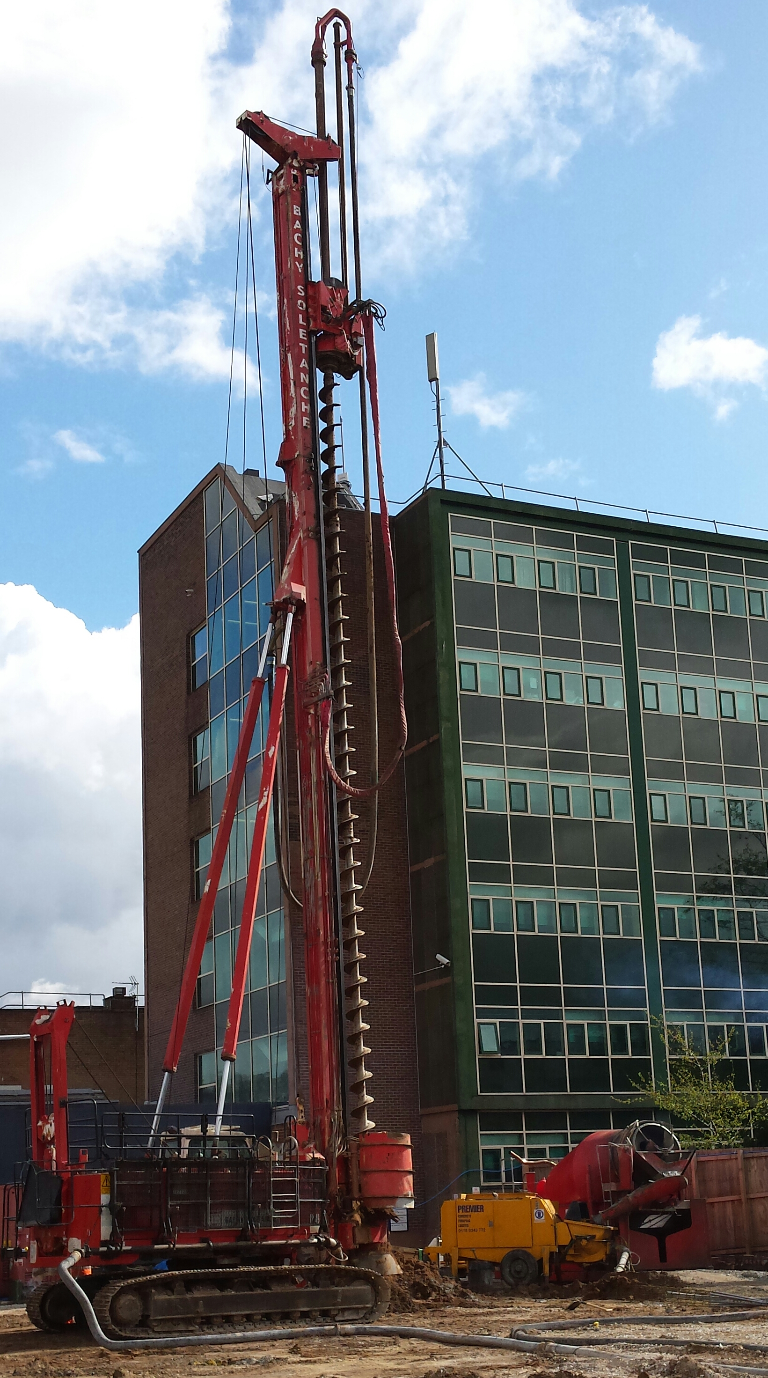
Figure 1
- Planning and Management of the Concrete Pumping Process

Planning Arrangements
A competent person representing the piling contractor shall plan the piling works in liaison with the Principal Contractor. A working platform certificate, safe system of work and project specific risk assessment must be in place prior to work commencing.

Selection of plant, equipment, pipeline and pumping equipment for the work must be carried out by a competent person.

Arrangements for the safe delivery of plant and equipment must be agreed with the Principal Contractor prior to work commencing.

Designated areas and routes for the rig, pipeline, pumping equipment, materials and concrete deliveries must be agreed with the Principal Contractors and communicated to all contractors during their site induction.

Concrete hose crossing points should be clearly identifiable and evident to all site traffic

Consideration must be given to the location of the pumping equipment in relation to the works and the route of the ground pipeline in relation to the Plant and Vehicle Management Plan.

Note: The location of the pumping equipment will require regular, possibly daily review, during the course of the works.

Pipeline Management.
All reinforced rubber hose must be uniquely identified. A record of its inspection and test must be readily available at site.

Where necessary and site conditions permitting, the use of steel concrete pipelines may be an option if an undisturbed run of pipeline can be established and used for extended periods.

Designated crossing points must be agreed with the Principal Contractor so that site plant and vehicles can cross the pipelines without damaging them.

The crossing points must be suitable and of sufficient strength to provide adequate protection to the pipeline.

Movement of pipeline (Both ground reinforced rubber hose and reinforced rubber loop hose on the rig) must take into account the bend radius to avoid kinks or sharp bends, which will cause internal damage.

Note: Reinforced rubber hose that has been subject to crushing by plant and vehicles will sustain internal damage, which may lead to premature failure of the hose.

Where stillage’s are used to transport pipeline, these must be subject to an appropriate inspection in accordance with current legislation.

Equipment Deliveries to and from Site
Procedures must be in place to ensure the safe loading and unloading of; plant, equipment, pipeline and pumping equipment. Consideration should be made for the safe working practice when working at height on the back of vehicles. Appropriate control measures will need to be in place.

Communication during the Pile Formation Process
It is essential that effective communication (Visual, radio or other means) is maintained between the concrete pump operator, the rig attendant and the rig operator at all times.

Forming the Pile
All works forming the pile shall be carried out in accordance with procedures, a safe system(s) of work and risk assessment(s), which must have been communicated to all those involved in the process prior to the work commencing.

Dealing with Blockages within the Concrete Pumping System
Under no circumstance must compressed air be used in an attempt to clear a blockage

Procedures must detail safe methods of clearing blockages, which must be communicated to the piling operatives prior to the commencement of work. Procedures must include the following:
- General safety precautions
  - Work at height.
  - Manual handling.
  - Working with pressurised systems.
  - Exclusion zones and restricted working areas.
  - Working with concrete.
  - Personal Protective Equipment (PPE) requirements.
- Assessment of the blockage and determining the action plan on how to deal with the blockage:
  - Consideration of how long clearance work can progress before the pipeline needs to be washed out.
  - Locating the blockage within the pipeline.
  - Dealing with blockages in the ground pipeline.
  - Dealing with blockages on concrete delivery system on the rig, including within the augers.

Cleaning the Concrete Pumping System
Procedures must detail safe methods of cleaning the concrete pumping system, which must be communicated to the piling operatives prior to the commencement of work. Procedures must include the following:
- General safety precautions
  - Work at Height
  - Use of compressed air
  - Working with pressurised system.
  - Exclusion zones and restricted working areas.
  - Manual handling
  - Working with concrete
  - Personal Protective Equipment (PPE) requirements
- Cleaning out the concrete pump and agitator.
- Cleaning out the pipelines:
  - Use of the blow out adaptor.
  - Ball catching arrangements.
  - Means of containment of spent concrete (Typical examples are shown in Figs 2 and 3).
- Arrangement for dealing with wash out water.

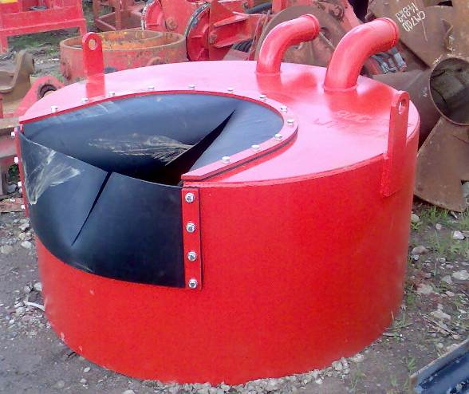 | 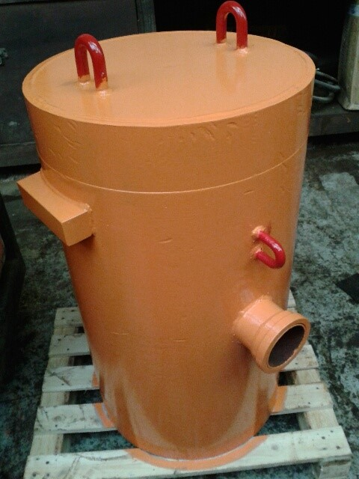
Fig 2 | Fig 3

- Maintenance
Procedures must be in place to rectify any faulty or defective equipment as soon as practicable in a safe and controlled manner. If defective equipment is unsafe to use or if there is any doubt on its safety then it must be immediately removed from service until it is made safe to use.

A robust maintenance scheme must be in place and carried out by competent personnel. Records of maintenance activities must be maintained and made readily available at site. The scheme should include the following for each component of the concrete pumping process:

Concrete Pump and Agitator
Maintenance shall be carried out in accordance with the manufacturers’ instructions.

Drilling and Piling Rig
Maintenance shall be carried out in accordance with the manufacturers’ instructions.

Cleaning Out Accessories
- Periodic inspection & maintenance of Blow Out Adaptor.
- Inspection of Blow Out Containment Chamber.
- Inspection of containment vessel/chamber for spent concrete.

Ground Pipeline
Maintenance of the pipeline shall consist of:
- Reinforced Rubber Hose
  - Pre-use visual checks for damage, coupling security (Where necessary placement of securing split pins), crossing points and where required fitting of safety slings (Whip-check).
  - Pressure testing to 110% of the working pressure as stated on the reinforced rubber hose which is held for a minimum of 2 minutes every six months (minimum).
- Steel Pipeline
  - Pre-use visual checks for damage, coupling security and crossing points.
  - Ultrasonic testing every six months to measure pipeline wall thickness. The steel pipeline is to be rejected if the thickness falls below 2 mm.

Concrete Delivery System on the Rig
Maintenance of the concrete delivery system shall consist of:
- Reinforced Rubber Loop Hoses
  - Regular visual checks for damage, coupling security (Where necessary placement of securing split pins) and where required fitting of safety slings.
  - Pressure tested to 110% of the working pressure as stated on the reinforced rubber hose which is held for a minimum of 2 minutes every twelve months.
- Steel Pipeline, Elbow and Swan Neck
  - Pre-use visual check for damage, coupling security (Where necessary placement of securing pins) and where required fitting of safety slings (Whip-check).
  - Ultrasonic testing every six months to measure pipeline wall thickness. The steel pipeline, elbow and swan neck is to be rejected if the thickness falls below 3mm.
- Concrete Swivel shall be maintained in accordance with the manufacturers’ instructions.
Appendix A
Legislation and Standards
The following list, whilst not exhaustive, gives some of the more important legislation which may be applicable in Great Britain. In other countries, reference should be made to the appropriate national legislation.

Legislation
Machinery Directive 2006/42/
Health and Safety at Work Act 1974
Management of Health and Safety Regulations 1999
Provision and Use of Work Equipment Regulations 1998
Supply of Machinery (Safety) Regulations 2008
Construction (Design and Management) Regulations 2015
Manual Handling at Work Regulations 1992 as amended in 2002
Personal Protective Equipment at Work Regulations 1992
Work at Height Regulations 2005/SI735

The Control of Substances Hazardous to Health Regulations 2002
The Control of Noise at Work Regulations 2005

Standards
EN 16228 Parts 1 to 7; Drilling and foundation equipment, Safety Requirements
BS EN ISO 14121-1; Safety of Machinery, Risk Assessment Principles
BS EN ISO 12100, General Principles for Design, Risk Assessment and Risk Reduction
BS 8476, Code of Practice for the Safe Use of Concrete Pumps
BS EN 12001, Conveying, Spraying and Placing Machines for Concrete and Mortar – Safety requirements.
PD 5304:2005, Guidance on safe use of machinery.

Other Publications
Construction Plant-hire Association (CPA) Good Practice Guide ‘Safe Use of Concrete Pumps’
HSE Leaflet INDG218 – Guide to Risk Assessment.
HSE Leaflet INDG163 – Five Steps to Risk Assessment.

