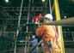
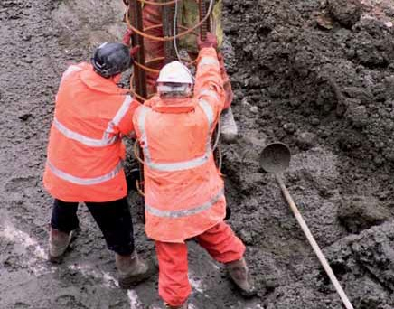

ISBN 978-1-85751-110-9

9 7 1109 >

CITB-Construc:tionSkills, CIC and CITB Northern Ireland are working as ConstructionSkills, the Sector Skills Council for Construction (CITB-Construc:tionSkills registered charity number 264289)

COMPANY

Safety on piling sites

Name of copy holder

I acknowledge receipt of a copy of the
Safety on piling sites booklet.

Signature

Issued by

Date

Do not work under the influence of drink or drugs –
MISJUDGEMENT CAN KILL YOU

GE 708

Published by ConstructionSkills, Bircham Newton, King’s Lynn, Norfolk PE31 6RH
in association with the Federation of Piling Specialists

© Construction Industry Training Board 1991

The Construction Industry Training Board otherwise known as CITB-ConstructionSkills and ConstructionSkills is a registered charity (Charity Number: 264289)

First published 1991
Revised 1999
Revised 2005
Revised 2007

ISBN: 978-1-85751-110-9

ConstructionSkills has made every effort to ensure that the information contained within this publication is accurate. Its content should be used as guidance material and not as a replacement for current regulations or existing standards.

All rights reserved. No part of this publication may be reproduced, stored in a retrieval system or transmitted in any form or by any means, electronic, mechanical, photocopying, recording or otherwise, without the prior permission in writing from ConstructionSkills.

Contents

Introduction v

General guidelines
1. Safety, the law and you 1
2. Piling terminology 3
3. Site preparation 6
4. Rigging and de-rigging 8
5. Use of cranes 9
6. Slinging and lifting 11
7. Ladders and access to rigs 16
8. Use of dumpers 19
9. Rough terrain forklifts 21
10. Abrasive wheels and grinders 22
11. Ready-mixed concrete trucks 24
12. Reinforcement and cages 25
13. Cutting, burning and welding 26
14. LPG and compressed gases 28
15. Services – overhead and underground 29
16. Work on contaminated ground 31
17. Welfare 33
18. First aid 34
19. Fire 35
20. Personal protection 37
21. Noise 43
22. Hazardous substances 44
23. Protection of the public 46

Specific types of piling
24. Driven piling 47
25. Sheet piling 49
26. Rotary bored piling 51
27. Descent of pile shafts 52
28. CFA (continuous flight auger) piling 53
29. Tripod piling 55
30. Diaphragm walls and barrettes 58
31. Vibrocompaction 59
32. Concrete pumping 61

Introduction

Many people are killed each year – and many thousands seriously injured – through accidents on construction sites. Safety concerns everybody: you and your workmates as well as your family and friends. Accidents are bad for you and expensive for the company, involving damage to equipment and materials, and adding delay and extra cost to the job.

This booklet is published by ConstructionSkills. It has been written by the Federation of Piling Specialists, an organisation dedicated to improving safety for everyone working in the piling industry. It is about safety awareness and preventing accidents at work, and aims to provide a basic understanding of safety
as it affects your work. It is divided into sections, each of which deals with a particular aspect of piling work.

Safety awareness is the key to preventing accidents. You should always follow the safety rules in this booklet. Piling work involves the skilful use of heavyweight plant, machinery, rigs and piles. One moment of carelessness could be your last.

The Construction (Design and Management) Regulations 2015 place a legal duty on all employers to ensure that anyone they put to work is competent to do their job without affecting the health and safety of themselves or anyone else.

If you feel that you do not have the required level of competence, or otherwise feel comfortable to do what is asked of you in a safe manner, you must stop what you are doing and tell someone.

Be aware: stay alive

General guidelines

1. Safety, the law and you.

A law was introduced in 1974 to protect people at work and anyone who might be affected by the actions of people at work.
It is called the ‘Health and Safety at Work etc. Act’. The Act concerns both employers and employees,
and makes people responsible for their actions as
well as their omissions.

It is your duty to take reasonable care for the health and safety of yourself and others who may be affected by your acts and ommissions. This means that you are responsible for what you do (and also what you don’t do).

It is your duty to co-operate with your employer on all safety matters and not to misuse any equipment provided.

Penalties for not complying with the law can be severe: a heavy fine or even imprisonment in the worst cases.

Regulations and Codes of Practice

The government also makes regulations concerning particular hazards. These are intended to be practical, and relate to basic requirements.

Examples of regulations applying to piling and construction sites are:

• The Personal Protective Equipment at Work
Regulations 1992

• The Manual Handling Operations Regulations
1992

• The Provision and Use of Work Equipment
Regulations 1998

• The Lifting Operations and Lifting Equipment
Regulations 1998

• The Management of Health and Safety at Work
Regulations 1999

• The Work at Height Regulations 2005

• The Control of Noise at Work Regulations 2006

• The Control of Vibration at Work Regulations
2006

• The Construction (Design and Management) Regulations 2007

Codes of Practice and Guidance Notes explain the practical application of these regulations.

Extracts from regulations are usually found in notices, company instructions, booklets etc. Read them carefully and follow them.

2. Piling terminology

Brothers Common term for two-, four- or multi-leg lifting chains

Cathead Top of leaders – sheave arrangement

CFA Continuous flight auger

Dolly Packing in drive helmet, takes blow from hammer

Drive helmet Sits on top of the pile

Drive shoe Non-recoverable plate on bottom of tube when driven into ground

Extraction collar Means of extracting tube by ropes over cathead to base machine

Ganger Works under a supervisor controlling a small group of people with plant and machinery undertaking a specific task

Grillage Framework to support
Kentledge

Hammer Used to drive the pile into ground. May either fit into hammer guide on leaders or may be freely suspended. Is attached to base machine by rope over cathead or boom

Kelly bar Provides drive between tool and rig motor

Kentledge Weights – normally concrete or steel

Leaders Either fixed directly to the rig or suspended from the boom, they provide a guide for the hammer or vibrator and the pile in
pile-driving operations

Mast Does same job as leaders but is fixed to the rig and equipment is guided by
the front face

Rake – forward Leaders, mast or kelly backward angled to guide the pile
into ground at an angle instead of vertical

Spare bond, Auxiliary hoist rope whip line or (i.e. one not involved second line in hammer or auger
hoisting)

Spotter arms Attachment between leader and base machine or mast and precast pile

Topman Piling operative – climbs the leaders or piling frame

Turnbuckle Joins two anchor rods or other threaded items

Vibrator Used to drive and extract casings, steel piles or cages

3. Site preparation

If piling operations are needed it is likely that the ground is poor in the first place. A firm, level platform is essential for the safe operation of a piling rig.

A firm, level working surface – together with suitable access – must be prepared before the arrival of a piling rig on site.

It is important that this is maintained for the duration of the work.

Most piling contractors now include the requirement for a certificate that shows this is done, signed by the organisation responsible, in their contract agreements. Check each time you go to a new site.

Do not relax because a certificate is in place – things change. Be alert for these points:

• Is there a firm, level base from which to work?

• Has any standing water affected the platform or access?

• Don’t walk through puddles – the holes may be deeper than you think.

• Check all gradients are within the safe working limits of the rig.

• Ask about underground obstructions, and the previous use of the site. Are there cellars or basements that have been filled in or left empty?

• Ask about underground services. Is there a
Permit to Work system?

• Check for overhead cables. Will the rig pass under them or will you be required to work close to them?

• Check the area set aside for materials, storage and offices. Make sure that there will be as little double handling as possible.

• Is it secure enough to keep out the general public, especially children?

Only when everybody is satisfied with the answers to these questions can you start unloading the rig.

4. Rigging and de-rigging

Rigging and de-rigging may only be carried out under the supervision of a competent person authorised
by your company.

The correct safe procedure is set out in the manufacturer’s or operator’s handbook. The correct sequence and safety precautions must be followed. Particular attention should be paid to the following:

• Stand well clear unless you have a particular task to do.

• Wear a harness when climbing. Use it when working at a height.

• Do not hold pins which need driving with a hammer; use the tongs or special tool provided and wear eye protection.

• Check that all equipment is complete and serviceable and that it is properly slung using the correct tackle.

• Check that all warning devices are working properly after rigging and before starting lifting duties.

• Check that all necessary actions are entered in the F91 or equivalent record book.

Take nothing for granted:
always check it!

5. Use of cranes

Many accidents involve cranes. You must follow these guidelines:

• Cranes must only be operated by authorised, trained and competent operators.

• Cranes must be mechanically sound and must be inspected at least weekly.

• A copy of the last thorough examination certificate should be available.

• Know the weight of the loads to be lifted.

• Do not exceed the limits of the equipment in use.

• Check for obstacles – ramps, slopes, buildings, trees, ducts, excavations, overhead cables, poor ground conditions, etc.

• Have a slinger/signaller in attendance during all lifting operations.

• Ensure that cranes are sited on level and firm ground for all operations.

Do not:

• obstruct crane controls or store loose items in the cabin

• operate in the vicinity of overhead wires without consulting your supervisor

• attempt to carry out adjustments or repairs if not authorised to do so

• carry out tandem lifts unless they have been properly planned and authorised by a competent person

• leave the crane engine running when it is left unattended

• leave crane unattended with a load on the hook

• travel or slew the crane without a banksman in attendance to check route and clearance, including overhead obstructions.

6. Slinging and lifting

Take care when slinging loads. Slings, shackles and all lifting accessories must have safe working loads marked on them and current certificates must be available.

Correct fitting method of bulldog grips

It is very important that the grips should be correctly fitted so that the base or saddle bears on the ‘live’ part of the rope (which takes most of the strain), as the U bolt may deform the rope in contact with it, and so reduce the working capacity. The number of bulldog grips to be fitted depends on the size of
the rope.

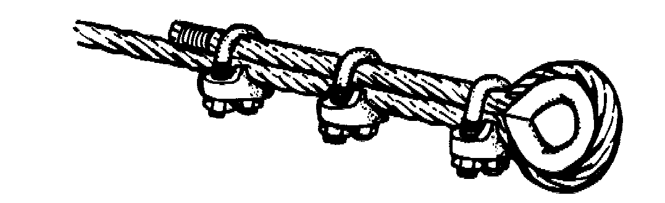

Checklist

• Only a competent and authorised slinger/signaller should sling loads.

• Check that the lifting accessory is of correct capacity. The safe working load of a sling is greatly reduced at angles over 90° (see diagram on page 15).

• Know the weight of the load to be lifted – remember to include the weight of the lifting accessories in use.

• Ensure that loads are balanced and evenly slung.

• Lift load slightly and check for stability and angle.

• Use tail ropes (tag lines or steady ropes) to control the movement of the load, especially in windy conditions.

• Use clear precise hand signals – one person only.

• Be very careful when lifting loads near people.

• Have a suitable platform prepared for landing the load.

• Loads should be landed on blocks and wedged where necessary to allow free removal of chains or slings.

Do not:

• use old lifting tackle found on site

• use chains which have knots or have been shortened by the use of bolts

• use links, rings or shackles unless they are large enough to ride freely on the hook

• allow slings to pass over sharp edges which may cause damage

• allow unused sling legs to swing around when lifting a load: put them on the hook

• snatch loads

• allow people to ride on loads

• direct loads over any person’s head

• allow loads to be lifted by the use of wire ties, binding wires, straps or packaging

• drag loads from trailer platforms

• allow people to work under loads.

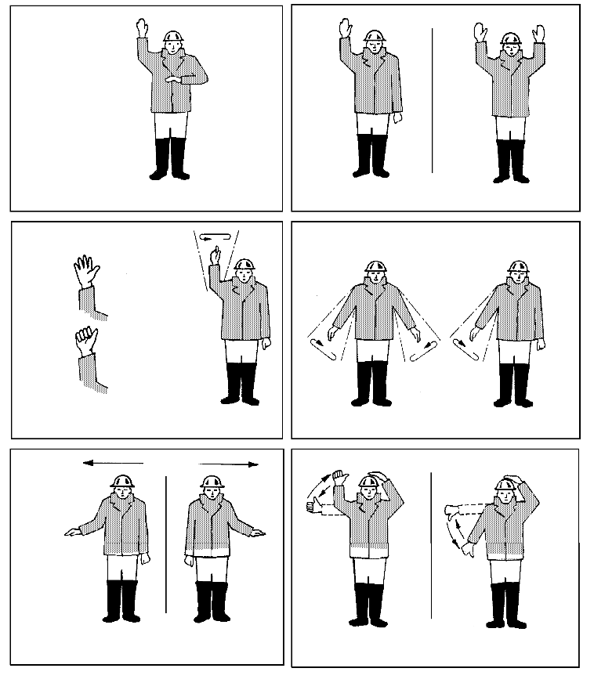
Crane signals BS 7121 (1989)

Operations start
(follow my instructions) Stop Emergency stop

Clench and unclench fingers to signal
‘inch the load’

Hoist
Lower slowly Lower

Slew in direction indicated
Jib up Jib down
Derricking jib

Slew with one hand; other hand on head
Signal with both hands

Travel to me Travel from me

Extend jib Retract jib

Travel in direction indicated
Operations cease
or cease to follow my instructions

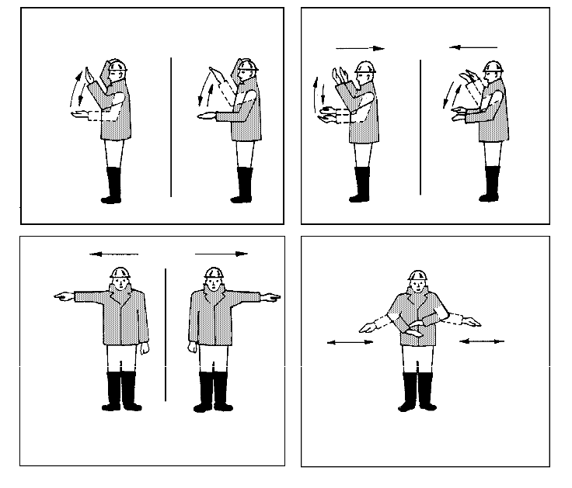
The signaller should stand in a safe place where they can see the load and can be seen clearly by the driver. The signaller should face the driver if possible. Each signal should be distinct and clear.

Load varies with sling angle

10tonn1s

7. Ladders and access to rigs

Many serious injuries result from misuse of ladders. Follow these guidelines.

Before use, check:

• Does the ladder extend at least 1 m above the landing place?

• Are the rungs and stiles in good condition?

• Is the ladder warped, sagging or distorted?

• Are the rungs oily or greasy?

Set up the ladder. Check:

• Is the base level and firm?

• Is the ladder in a safe place where it won’t be struck by vehicles, machinery or be dislodged?

• Is the ladder the right way up with the strengthener rods under the rungs?

• Is the ladder set up to approximately 75° or one out to four up?

• Is it secure against displacement? (If not it requires tying or ‘footing’.)

• If it is an extending ladder, does it overlap by at least four rungs?

• Does the ladder extend at least 1 m above the landing place?

NOTE: Due to changes in health and safety law you may find that you are now not allowed to use a ladder for some jobs that you would have used one for in the past.

Ladderways
(rungs or loops fixed to masts, etc.)

• Look for damaged welds.

• Look for missing rungs.

• Look for damaged rungs.

• Report any problems to your supervisor. Get repairs made urgently.

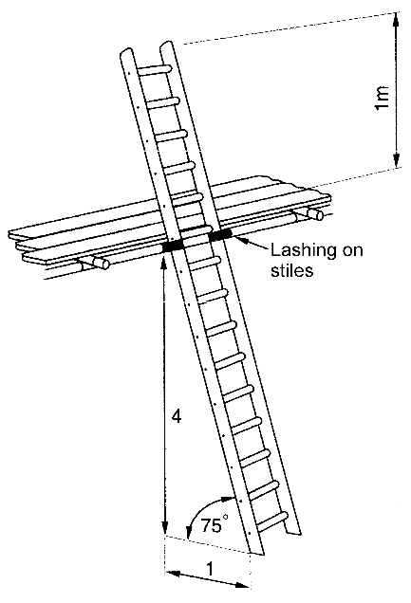
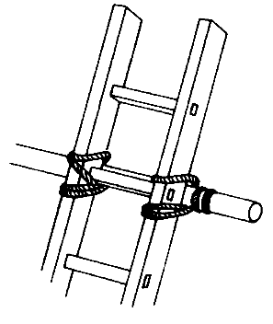
• Wear a safety belt or harness and restraint lanyard when work has to be done from any ladderway or unfenced platform.

Climb and work safely

• Wear non-slip boots – try to avoid mud, grease and oil.

• Keep both hands on the ladder when climbing.

• Carry small tools in a belt.

• Hoist larger tools and materials up after you reach the top.

• Only one person at a time should be on the ladder. Wait until it’s clear before taking your turn.

• Don’t rush when climbing, and don’t slide down or jump off ladders.

• Face ladder – and avoid twisting and turning.

• Keep one hand on the ladder when working.

• Use a safety harness properly attached to the structure when you need your hands free for working.

• Don’t reach too far when working. If your body isn’t within the stiles, you’re leaning too far! Move the ladder.

• Watch out for people below and be careful with tools and equipment.

• Beware of overhead hazards – use extra care near electricity cables.

• Never step on the top four rungs – get a longer ladder.

8. Use of dumpers

Dumper drivers must be at least 18 years old. They must be authorised, trained and competent.

Do not:

• operate any controls unless seated on the machine

• obscure the driver’s view with load

• carry passengers, unless on a proper fixed passenger seat

• drive too fast

• drive across slopes (risk of overturning)

• stay on dumper when it is being loaded

• travel with skip up.

Do:

• check the machine daily and weekly and report defects

• use seat belt for every journey

• hold starting handle correctly

• distribute loads evenly and avoid overloading

• flag projecting loads

• remember that wet brakes don’t work as well as dry brakes

• always use stop blocks when tipping into excavations, etc.

Do:

• apply hand brake when stationary

• put gear lever in neutral when parked

• chock wheels when parked on slopes.

People working nearby should always keep clear of the machine operating routes and be aware of what is happening around them.

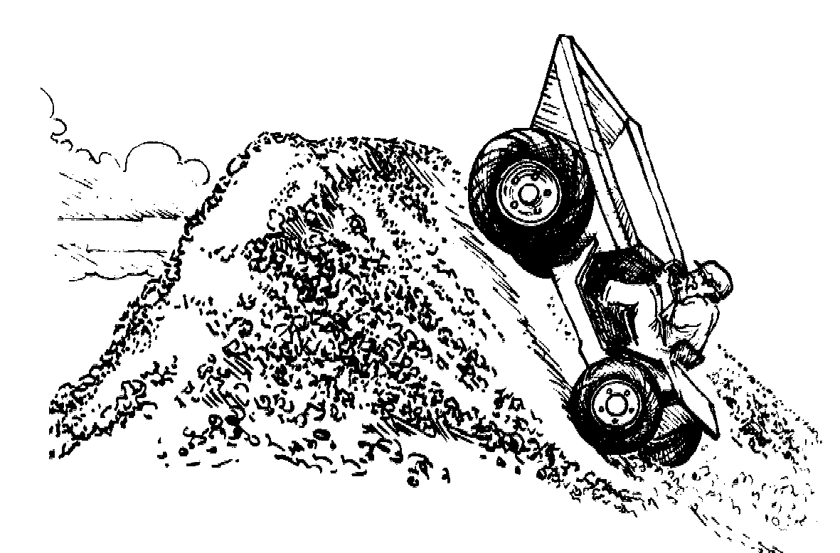

Gradients and slopes can be a problem on site

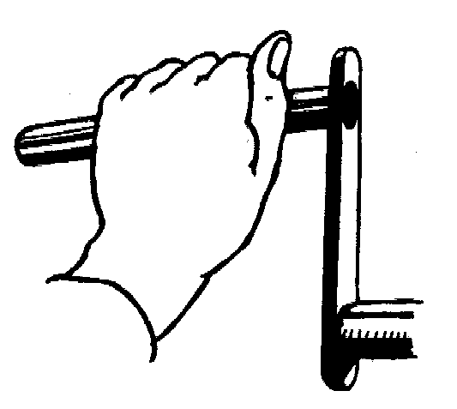

Grasp starting handle correctly

9. Rough terrain forklifts

Drivers of rough terrain forklifts must be at least
18 years old. They must be authorised, trained and competent.

Drivers must:

• know the limits of the machine and not carry passengers

• carry loads with the mast vertical or tilted slightly backwards

• position load tightly to the mast

• set forks to maximum spacing possible in relation to load

• ensure the load does not obscure their view. If it does, they should travel in reverse or use a banksman

• travel with load at lowest level possible and don’t raise when travelling

• on slopes, face the load uphill. This means reversing to go downhill

• not drive across slopes

• check for overhead obstructions when mast is extended

• when parking: lower forks to the ground, apply handbrake and remove the ignition key

• when travelling unloaded: make sure that forks face downhill with tilt to suit the gradient.

10. Abrasive wheels and grinders

Injuries from the misuse of abrasive wheels are caused by:

• particles produced during cutting or grinding

• disintegrating wheels

• contact with the revolving wheel

• heat generated in material being cut and in tools.

Mounting abrasive wheels

Do not mount an abrasive wheel unless:

• you have received proper training

• you are competent to do the job

• you have been authorised (in writing) by your employer to do so.

The maximum speed marked on the disc must be the same or greater than that marked on the machine.

The centre hole of the wheel should match the spindle so that it fits easily but not loosely.

Using an abrasive wheel

• Do not smoke or have the engine running while refuelling petrol-driven machines.

• Do not use the machine above shoulder height.

• Do not operate the machine without the guard in position.

Always:

• wear protection, particularly goggles, gloves, safety footwear and ear defenders

• work out the cutting direction before starting to cut at maximum speed

• use the right disc for the job

• make sure that the workpiece will stay still during cutting/grinding.

Wear a safety helmet Wear eye protection

Wear ear protection Wear safety footwear

11. Ready-mixed concrete trucks

Full ready-mixed concrete trucks are top heavy with heavily loaded rear wheels.

In general

• Take extra care where trucks have to go on slopes or gradients.

• Traversing slopes should be avoided. Do not drive across slopes.

• Remember that the ground may be soft or slippery and cause problems for the driver.

• Watch out for projecting reinforcement and back- filled bores, especially if the site is covered in slurry.

When reversing

• A banksman must always be present to give clear signals to the driver and to ensure safety at the rear of the vehicle.

• Wheel stops should be provided to prevent the vehicle from getting too close to the edge of excavations, piles, or concrete pumps.

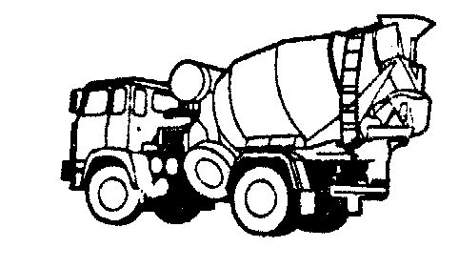

12. Reinforcement and cages

When off-loading and stocking steel reinforcement, make sure it is in a stable position, out of the mud and with supports to allow re-slinging. Sling around the bundle. Don’t use the binding wire.

Remember:

• Use the safe method of working drawn up for making cages. The trestles should be stable at all times.

• Lift bars properly with back straight, knees bent, elbows in, head up and feet slightly apart.

• After tying, bend any protruding wire back into the cage.

• Don’t leave tying wire around the site: it is a trip hazard.

• Only lift at designated lifting points. If in doubt, ask.

• Lift completed cages using proper slings and tag ropes where necessary. Do not sling from the ties.

• For large cages, purpose-built lifting beams may be required.

• Many injuries could be avoided by wearing gloves.

• Minor injuries, cuts, grazes and puncture wounds caused by reinforcement/tie wire should be cleaned and treated, otherwise serious infection can develop.

• Report and record all injuries.

13. Cutting, burning and welding

Cutting, burning and welding should only be done by people who are authorised, trained and competent.

Remember:

• Examine equipment before use to ensure that there are no gas leaks.

• Ventilation is essential when cutting or welding.

• Mixtures of propane or acetylene gas in the air can explode.

• Acetylene is liable to explode when under excessive pressure.

• The correct nozzle must be used for the type of gas being used.

• Flash-back arrestors must be fitted.

• All arc welding cables and connections should be sound and of adequate size.

• The earthing connection for the welding circuit must be properly made.

• Where two or more welding machines are being used, the earthing arrangements should be supervised by a competent person.

• Wear proper eye protection.

• Use screens when arc welding.

• Keep fire extinguishers near to the work.

Fire

Before starting any welding or cutting, all combustible materials must be moved out of reach of flying sparks and spatter. If this is impossible, they should be protected with sheet metal or fireproof sheeting. Tarpaulin must never be used.

Suitable fire extinguishers should always be available nearby.

Oxygen must never be released to ‘sweeten’ the atmosphere in a confined space. Clothing and other materials self-ignite in oxygen.

Fume risks

Dangerous fumes are given off when some coated or treated materials are cut or welded. Special care
must be taken about ventilation.

Flash risks

Your eyes can be seriously damaged if you look directly or indirectly at the intense light produced by arc welding. Screen the work area.

14. LPG and compressed gases

Cylinders which contain gas at high pressure must be treated with care. Do not knock or damage the valve assembly or use it to lift the cylinder.

Fuel gas (acetylene, butane and propane
(LPG)) and oxygen cylinders

Do always:

• handle cylinders carefully, store and use vertically
• ensure proper high- and low-level ventilation when used in site huts and offices and when being transported. Vents must never be covered

• store cylinders in a lockable, well ventilated store, cage or compound

• see that correct fittings are used and threads are correctly matched.

Do not:

• sling cylinders by the neck or valve

• allow oils or grease to come into contact with valves or fittings – danger of explosion

• mistreat cylinders – they look like bombs and have the same destructive potential. Treat them as you would a bomb

• test for leaks using naked flame: use soapy water.

The transport of bottled gases on public roads normally requires the display of a hazard plate and the carrying of fire extinguishers and TREMCARDs.

Consult your supervisor for details.

15. Services – overhead and underground

Overhead lines

Contact with overhead lines is the cause of many accidents and serious injuries in the piling industry.

• You should assume that all overhead lines are live until told otherwise. Even low voltages can kill.

• Do not use rigs or cranes near overhead power lines without permission from your supervisor.

• Do not assume you can work near an overhead line because it looks safe. It is very difficult to judge distances when looking into the sky.

• Where plant has to operate near overhead lines, you should be informed of the proper precautions which must be taken (such as using goalposts and warning barriers).

• Report immediately if any precautions are defective.

Buried cables, pipes, etc.

All buried services should be known to your supervisor before work starts. Beware – unmarked services may still exist!

Always:

• follow instructions given

• stop as soon as you find an unmarked pipe or cable

• treat all cables and pipes as live until told otherwise
• follow any permit system.

Take care when working near overhead power lines

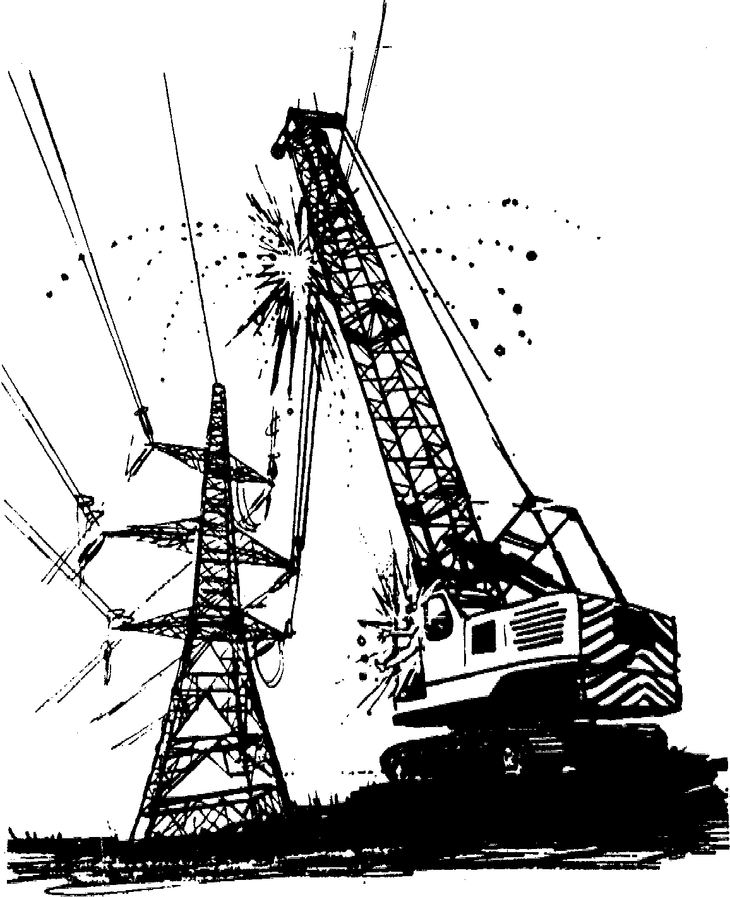

16. Work on contaminated ground

Land contaminated by previous use can often conceal hidden dangers. Your company will have a site investigation report and, before work begins, will instruct you on any special precautions needed.

Contamination may only appear when spoil is exposed. Do not rely on being able to smell or see contamination, there are many sorts.

Gas monitors must be used to detect the presence of any toxic or flammable gases.

If the spoil has a high liquid content, splashes may come off the augers or other equipment.

Remember:

• Protect yourself.

• Eye protection (visors) should be worn to give full face cover.

• Wear gloves, waterproof safety footwear and overalls, even in hot weather. It is better to have the body covered than to get splashed by contaminated soil or liquids.

• Use barrier creams as advised.

Always:

• Be aware of the symptoms of fatigue and heat stress when wearing large amounts of personal protective equipment.

• Get treatment for any cuts and scratches and record them in the Accident Book.

• Wash properly before putting anything in your mouth, eating, drinking or using the toilet.

• Shower if possible at the end of a shift.

• Report headaches, sickness or diarrhoea to your supervisor and visit your doctor if it persists.

• Tell your supervisor of irregularities in the spoil; look for black sticky substances or brightly coloured powders.

Do not:

• smoke, eat or drink in the contaminated area

• go home in your working clothes

• compromise on personal hygiene.

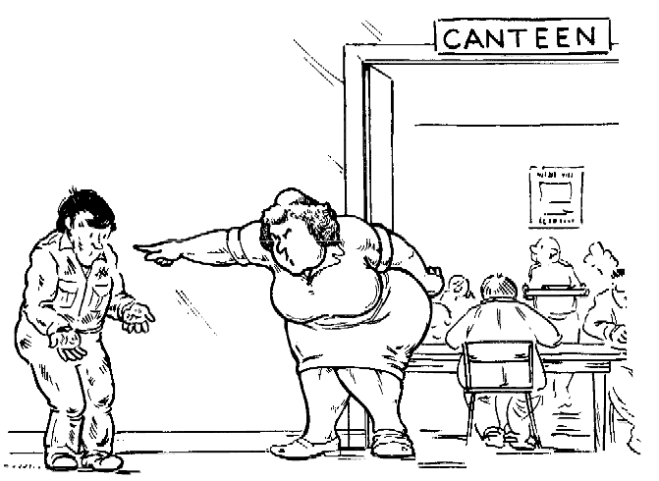

Remove outer clothes and wash hands before touching food or drink!

17. Welfare

Accommodation, messing and drying facilities, toilets and washing facilities will be provided. These must be kept clean and tidy at all times.

Remember:

• Always wash your hands before eating and drinking.

• Do not leave food lying around as it might attract vermin.

• Look after the accommodation – it’s your home for five days a week!

Accidents and accident reporting

Accidents must be reported to your supervisor. Ensure that they are properly recorded in the Accident Book.

The information from accident reports is used to improve safety on site.

Accident information recorded at the time may be used to support your claim for compensation. If not reported, there may be no evidence to support your claim.

18. First aid

Regulations state that employers have to provide adequate first-aid equipment and a sufficient number of trained first aiders.

Employees must be informed of these arrangements. Make sure that you know them. Who is your trained person and where is the first-aid box?

First-aid boxes should:

• contain first-aid equipment only

• be put where they can be seen and used. Signs outside the building containing first-aid boxes can help.

Action at an emergency

• Do not move the casualty, unless it is really necessary to do so.
• Make any casualties as comfortable as possible.
• No drinks, no food, no smoking!

Assess the situation

• Take in what has happened quickly and calmly.
• Look for dangers to yourself and to the casualty.
• Never put yourself at risk.

Make the area safe

• Protect the casualty from danger.
• Do not try to do too much yourself.

Get help

• Make sure that any necessary specialist help has been called and is on its way.

19. Fire

Everyone should know the risks of fire and the actions to be taken in the event of a fire.

• If you see a fire – raise the alarm before doing anything else.

• If there is a danger of fire, have an extinguisher with you.

• Know where extinguishers are kept.

• Know the correct type of extinguisher to use.

• Don’t smoke in prohibited areas.

• Switch off all equipment when not in use.

• Use the proper labelled containers for flammable liquids.

• Keep flammable materials away from sources of ignition.

• When drying clothes keep them well away from heat sources.

• Don’t allow rubbish or oily rags to accumulate.

• When naked flame equipment is used beware of the risk to materials nearby.

• If fire breaks out, try to extinguish it but do not put yourself in danger.

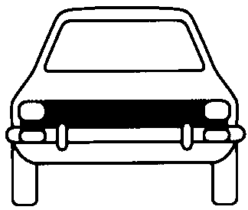
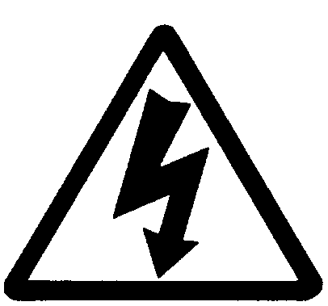

Fire extinguisher colour codes to BS EN 3 and BS 7863

EN 3 colour descriptors | Red with white band or label | Red with cream band or label | Red with black band or label | Red with blue band or label
Fire risk | WATER | FOAM | 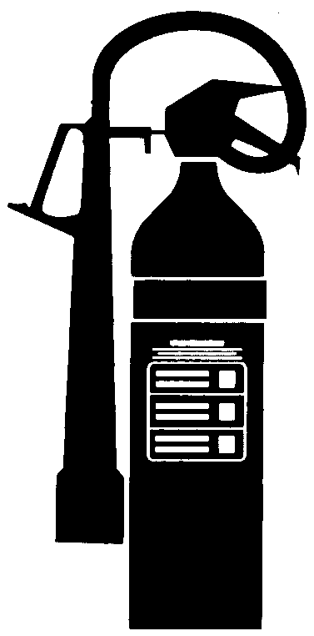  CO2 | POWDER
Colour | All red | Cream or red with cream label | Black or red with black label | Blue or red with blue label
Paper, wood, textile and fabric | ✓ |  |  | ✓
Flammable liquids |  | ✓ | ✓ | ✓
Flammable gases |  |  | ✓ | ✓
Electrical hazards |  |  | ✓ | ✓
Vehicle protection |  |  |  | ✓
BS 7863 colours of older models | Red | Cream | Black | Blue

20. Personal protection

Personal protective equipment must be provided by your employer where a risk cannot be practically removed. It is your last line of defence and should not be taken for granted. Some of the many simple ways in which you can help to reduce risks and reduce the need for personal protective equipment are given under specific headings in this book.

Number of reportable injuries 2004

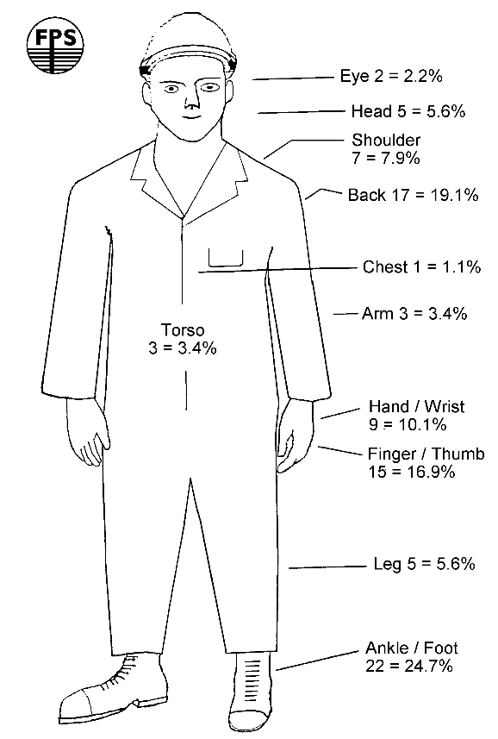
(Percentages = percentage of total injuries 2004)

Head

• Always wear a safety helmet on site; it’s a legal requirement as well as common sense.

• Check your helmet for damage; get a replacement if needed.

• Adjust it so that it fits you comfortably, without falling off.

• Fitted accessories available include visors, ear muffs, eye protection, winter liners and chin straps. Short peak versions are also available.

• Use the right combination of head gear for your job.

Eyes

Eye injuries are always serious. The law reflects this, requiring eye protection to be worn when:

• using disc cutters or grinding wheels

• using compressed air tools

• welding or cutting

• hitting masonry, concrete or metal with a hammer

• working with anything which might splash, including fluid concrete.

Ears

Excessive noise can cause deafness. Your ears never get used to it; you simply go deaf. The law requires that you are informed of noisy activities and that you use the correct hearing protection.

There are two basic types of hearing protection available:

• Ear muffs: helmet mounted, sprung band to fit round neck or head.

• Ear plugs: disposable (use once only), re-useable.

To avoid infection, pay particular attention to hygiene instructions.

Lungs

Injury and disease can be caused by the inhalation of harmful dust and fumes. Where these cannot be removed it is important to wear the correct mask. You also need to be instructed on the correct use and
care of these masks.

Types available include:

• disposable dust masks

• masks with special filters for particular dusts and fumes

• enclosed helmets with pressure-fed clean air.

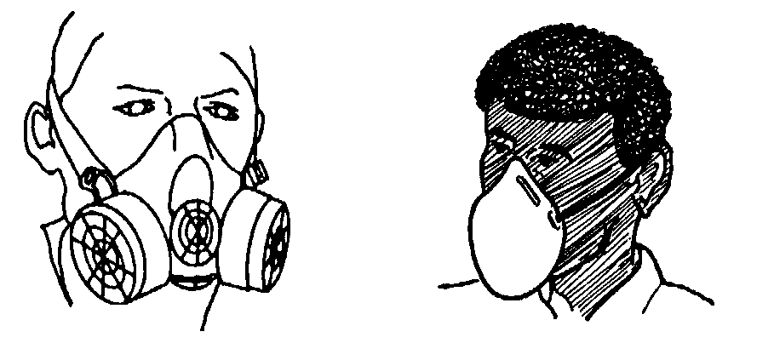
Half mask dust Disposable respirator respirator

Body

The basic principle is to protect as much skin as is practical, even in hot weather. Generally, protective clothing needs to be durable, easily fastened and lightweight.

Types of protective clothing include:

• boiler suits: disposable/conventional/flameproof.
Check fit and launder regularly

• waterproofs: single-piece suit, or jacket and trousers

• cold-weather jackets

• high-visibility clothing

• special chemical-protection suits.

Hands

Because our hands are used for most jobs, they are at greatest risk of injury and spreading harmful substances. The most common injuries are cuts and dermatitis.

• Use the right type of gloves for the job.

• Wash before eating or drinking, leaving the site, and before and after using the toilet.

• Get first aid for all cuts and injuries to avoid infection.

• Use barrier creams and skin cleansers.

• Don’t clean your hands with diesel, paraffin, petrol or other damaging liquids.

Feet

Most foot injuries are caused by things being dropped on the feet or by treading on sharp objects. Safety footwear should always be worn on sites. It should:

• be a good fit and comfortable

• have toe protection to a recognised standard

• have good soles for muddy and oily conditions:
mid sole protection is strongly recommended.

Falls from heights

Where work has to be done at height, fully fenced platforms and access give the best protection against falls. Where it is not practical to provide this, special equipment must be used to reduce the risk of injury from falls.

• People who are going to use it must be trained in its care and use.

• Equipment must be to approved safety standards
(CE or BS marked).

Specialist training will be given to users, but here are some general reminders:

• A safety belt alone is not safe for piling work because it can cause serious injury.

• Use a proper safety harness fitted with a restraint or shock absorbing lanyard as appropriate.

• Stay attached at all times when not on a safe platform.

• The attachment point should be above you to limit free fall.

• Use the shortest practical attachment line or retracting line.

• Check that the attachment point will carry your weight.

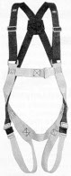

Safety harness

21. Noise

Excessive noise can damage hearing. You never get used to noise, you simply get more deaf and this may not become evident for years. The law requires that you are protected from excess noise.

You should:

• wear hearing protection when told to do so and in all noise control zones

• wear it properly, look after it and report defects

• try to keep away from noisy machines or noisy areas.

If normal conversation is difficult from a distance of about 2 m, there is a noise problem.

Reduce noise whenever possible

• Avoid metal-to-metal contact when hammering.

• Oil and grease machines frequently.

• Keep silencers and acoustic panels in place and keep engine doors closed.

• Keep plant well maintained.

Remember:

• Deafness is much more uncomfortable than wearing ear protectors.

• Hearing protection will safeguard the remaining hearing of those already partly deaf.

22. Hazardous substances

Many of the substances found on piling sites, such as fuels, lubricants, cement, concrete and dusts, represent a hazard to the health of people using them and may cause dermatitis and skin burns.

The purpose of the Control of Substances Hazardous to Health Regulations (COSHH) is to protect you, the workforce, from harmful materials at work.

Follow these simple rules:

• Read the COSHH assessment sheet.

• Learn how to use substances correctly and know the hazards.

• Practise safe working procedures.

• Report any hazard or defects to your supervisor.

• Store materials and equipment safely.

• Learn and remember the emergency actions.

• Use the personal protective equipment provided.

• Adopt a high standard of personal hygiene: always wash before putting anything near your mouth, before and after using the toilet and before leaving site.

Remember: if in doubt, ask!

Know these signs

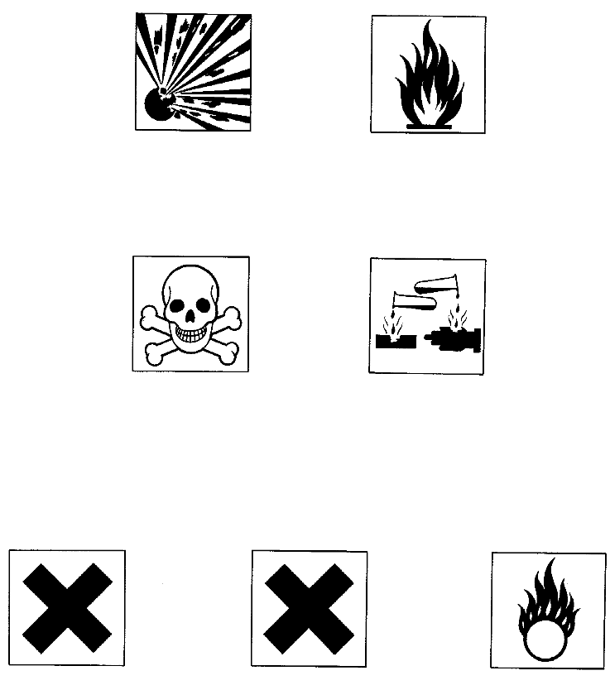
Danger symbols most commonly found in construction:

Explosive Highly flammable

Toxic Corrosive

Other danger symbols:

Harmful Irritant Oxidizing

23. Protection of the public

Piling and construction sites are hazardous and particularly attractive to children. If the public has access to your site, ensure that dangers from machines, rigs, cranes and excavators are controlled.

Always, and particularly at night:

• cover or fence all excavations and holes

• make sure that hoardings are in good order

• ensure that materials are stacked in a safe manner and not near fences

• guard or protect obvious hazards, such as chemicals, tools and fuel tanks

• keep gas supplies isolated and cylinders upright and in a locked enclosure

• remove access ladders

• immobilise all vehicles and plant.

Do not work under the influence of alcohol or drugs
MISJUDGEMENTS CAN KILL YOU

Specific types of piling

24. Driven piling

This operation includes the driving of pre-cast concrete, timber or steel piles. Although the general safety guidelines apply at all times, accident experience shows that the following points need to be stressed.

Do:

• take care not to trap fingers or hands in narrow spaces between piles and leaders

• stay clear of piles which may ‘spring’ if deflected after striking obstructions in the ground

• ensure fall protection measure are in place and used when working at height

• use the safety bar (monkey pin) when working beneath the hammer

• look out for tripping hazards, e.g. timbers, tools, marker pins

• always use your ear defenders when working near the pile hammer

• stay clear whilst piles are being driven, as materials may fall from height from damaged piles

• wear eye protection when looking up at the hammer

• be particularly aware of hazards during the marking of sets.

Do not:

• move out of view of the driver unless they know where you are and what you are doing

• pitch a precast pile using the lifting hook alone.
Always use a wire sling

• use the pile-pitching sling if it shows signs of damage

• free or re-align winch ropes on drums using your hands unless they are well clear of the drum.

Driven piling is noisy: when you see this sign, WEAR HEARING PROTECTION!

25. Sheet piling

• When temporary piles are used to support a gate system, use purpose-made brackets bolted to the piles if possible. If any welding is necessary it must be carried out by a competent welder.

• When using kelly blocks, ensure that they are properly set on firm foundations to prevent subsidence or overturning.

• If shackle holes have to be burned in piles,
remove sharp burrs to prevent damage to shackle pins.

• Use ground release shackles when possible;
check that the pin is engaged.

• When ropes are used to open shackles, ensure the ropes are shorter than the sheets and adequately fixed to prevent snagging.

• Access must be by man-riding cage or properly constructed scaffold.

• If practical, pitch long sheet piles with a pile threader to manufacturer’s guidance.

• When feeding piles through gates, use wooden blocks or a bent bar. A straight pinch bar can trap fingers and must not be used.

• When pitching from a ladder, it must be secured.

• When working at height always use a full safety harness with a shock absorbing lanyard. Keep as little slack in the lanyard as possible and attach it to a secure point above your waist, such as a pile already driven.

Piling hammers

• All hammers and clamping bolts must be inspected daily.

• Use a guide rope to position hammers.

• Stand clear when hammers are starting, operating or being lifted overhead.

• All workers must be at ground level while driving or extracting.

• Supply lines, cables, hoses, etc. must be properly made with matched couplings; they must be kept under constant observation.

• Where internal drop hammers or suspended hammers are used, a swivel must be placed between the hammer and the hoist rope.

Hydraulic vibrators

Extreme care must be exercised when using hydraulic vibrators. They must only be operated by trained and competent workers.

Check that:

• nuts and bolts are tight before use and not worn or damaged

• a safety check sling is connected between the vibrator and the casing or pile.

26. Rotary bored piling

• Always keep the spoil from boreholes as far away as possible.

• Maintain safe access to the borehole.

• Entry into boreholes less than 750 mm in diameter is prohibited.

• Where it is necessary to enter a borehole, special precautions are necessary – see ‘Descent of Pile Shafts’.

• All control levers on piling rigs should be marked to indicate their purpose and mode of operation.

• Always stand well clear of the auger both when drilling and discharging spoil.

• All ropes are subjected to heavy wear: they must be inspected frequently and changed as necessary.

• Do not climb up the auger when plumbing the kelly bar.

• The pile bore should always be protected to prevent anybody falling down it. Barriers, casings or covers should be used.

27. Descent of pile shafts

Personnel are required on occasions to descend large diameter (not less than 750 mm) pile shafts, either for purposes of inspection or for additional hand work such as cleaning out or extending the under-reamed base.

This activity is covered by detailed law and safety standards including BS 8008:1996.

Never attempt this without written instruction/ authorisation from your employer and then only after full training.

Detailed work procedures, method statements, training, practice and discussions with fire and ambulance services as part of the emergency planning are all required.

No smoking and no naked flames in or near bore holes or pile shafts

28. CFA (continuous flight auger)
piling

• Forward planning and using well maintained equipment is the safe way.

• Stability is an important factor with CFA rigs – check stability of the ground and use rig only with tracks extended or with stabilisers.

• Keep the piling platform clear of equipment and materials.

• Always use a safety harness if you have to go aloft on the rig.

• Keep looking up as well as around you –
frequently.

• Always cover or protect completed piles and protruding reinforcement.

• Know the limitations of the auxiliary winch and second line.

• Always secure loose items and hoses.

• Keep the drill gate closed when tracking.

• Only rig and de-rig on level ground.

• Spoil falling from augers is a potential killer.
Ensure that no spoil is left on the augers during extraction.

• Use a mechanical auger cleaner wherever it is available. In special circumstances other cleaning methods may be used on instruction. Remember that pumping of concrete can dislodge spoil and insertion of the reinforcing cage means being close to the auger.

• Check that grille on concrete pump is replaced before restarting engine after clearing a blockage.

• Cleaning out hoses using compressed air must be carried out strictly in accordance with your company’s procedures.

• Make sure everyone around you knows when the rig is moving and where to.

• Keep everyone away from the rig, the pump and hoses unless they are directly connected with the job.

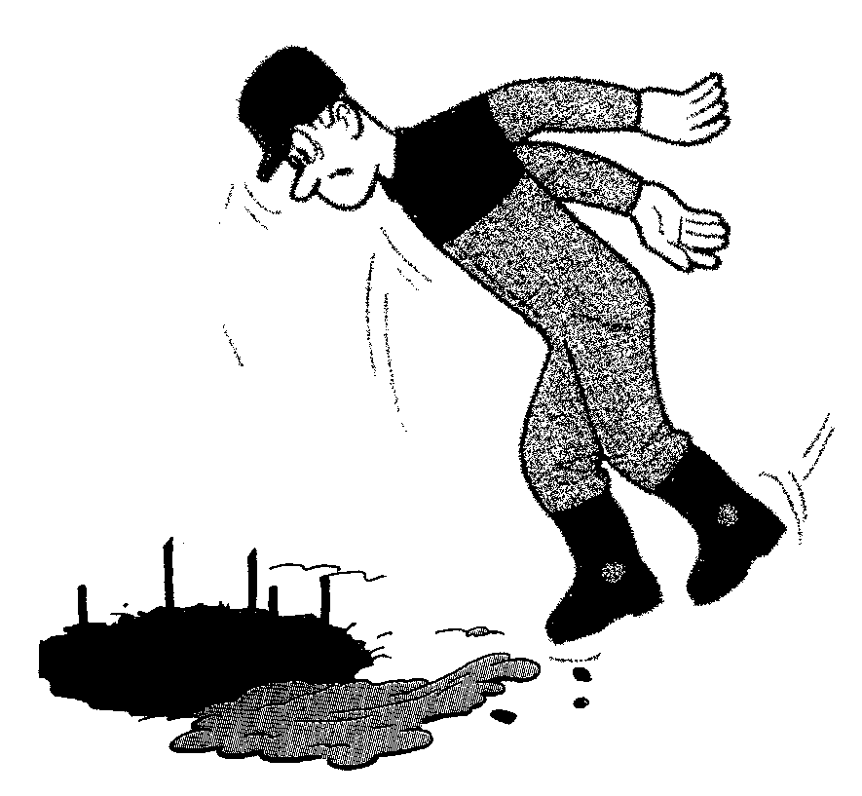

Beware of exposed re-bar!

29. Tripod piling

Tripod piling is more labour-intensive than most other forms so the risks are greater. Conditions underfoot can become very difficult with spoil, water and slurry. Driving casings can be especially noisy so wear ear defenders.

Before starting, make sure that the rig is stable and check for unseen hazards such as ducts, backfill, cellars and services.

While working

• Keep site clean and tidy and as free from mud and water as possible.

• Use a spot board for spoil until the first length of casing is inserted.

• Casing drive bar should have overhang of 150 mm each side.

• Dumpers used to collect spoil direct from the tool must be guided under the rig.

• Tipping hooks and rope must run parallel down the shell or pump.

• Never leave a bore top open when unattended, secure a tool in it near the top or use a cover.

• When completed, the pile should be covered.

• If climbing, follow the correct procedure.

Insertion of steel cages

• Cages must have sufficient ties or welds to give strong lifting points.

• Cages must be lifted by use of a shackle or hook with proper safety clip.

• Cages must be checked by a competent person before being lifted.

• Keep hands and feet clear during lowering.

• Bars used to support the weight of a cage within the bore must be of suitable length and strength.

When pouring concrete and pulling the casing

• Pour concrete through a hopper.

• Slings must be shackled to casings which are to be pulled.

• When casings are being pulled, everybody must stand clear.

• Do not overload the frame when pulling casings – use jacks, casing extractors or other safe methods.

• After pulling the casings the empty bore must be backfilled or protected.

• When washing out, ensure that washings do not go into rivers or drains.

When moving the rig and de-rigging

• Check the ground that the rig will pass over.

• Always try to pull over level ground.

• Beware of manholes and voids in the pulling path.

• When deadman anchor is used, ensure it is of sufficient strength.

• Take care when de-rigging – in particular avoid trapping hands and feet.

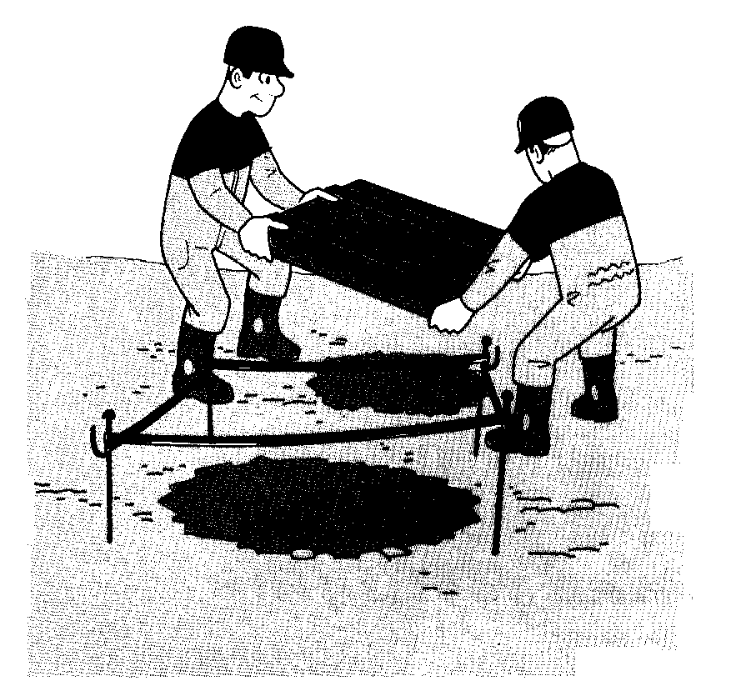

Never leave open bore holes unprotected

30. Diaphragm walls and barrettes

Take care when handling bentonite, both before and after mixing.

Know the COSHH assessments and precautions for using bentonite/drilling mud; in particular for the various additives in bentonite.

Because heavy cranes and loads are used in diaphragm wall construction, check that the working platform has a hard surface, is flat and is well maintained.

There should be a working platform certificate which tells you what should be there; but don’t rely on it, do your own checks.

Excavations full of drilling mud must be protected with a cover that cannot be moved by children.

When excavating and concreting, minimise the overflow of bentonite/drilling mud to prevent the site and working platform from becoming slippery or obscuring holes and other hazards.

Reinforcement cages for diaphragm walls and barrettes are usually large. Full method statements should be drawn up for the handling and placing of these cages, and they must be strictly followed, especially for dual lifts.

When putting the cage and tremie pipe into the excavation, make sure that arms, legs and feet are not trapped within the guide walls.

After concreting, the panel should be backfilled or covered to prevent people falling into the hole.

31. Vibrocompaction

A vibro poker is hung from a crane, penetrating the ground under its own weight aided by means of compressed air or water. The freedom of the poker depends on ground conditions.

Crane and working platform

• Check that the working platform is up to the job, don’t rely on the working platform certificate.

• Check that the crane is adequate for the job and properly set up.

Vibro poker

• Do not overload. When the amperage reading stated is achieved, stop, otherwise the motor will be burnt out.

• Take care in attaching the poker to the crane hook. Secure the safety catch to prevent hooks and block overrunning the load.

Electric cables

• With high-voltage cables, extreme care is needed by a competent person in making good, clean connections.

• Ensure that the connection plugs are clean, firm and protected from the weather.

• Cables left lying on the ground are easily damaged by tracked vehicles.

Generator

• Must be earthed.

• If fitted with automatic cut-out, test it daily.

• Know where the emergency shut off is.

When using water:

• Take care that excess water does not enter or disguise excavations.

• Excess water should be channelled into a lagoon to allow silt to settle and avoid pollution.

When using compressed air:

• know where the emergency shut off is

• restraints should be fitted at hose joints to stop whipping in case of a burst.

Vibrocat

This is purpose-built plant with a poker held on a mast and a stone skip.

• Ground conditions must be suitable to take the weight.

• Outrigger jacks must always be used when probing.

• The mast must be laid back over the plant when traversing the site.

• The stone skip must not be overfilled.

32. Concrete pumping

When you get it right, pumping concrete makes light work of a hard job. However, get it wrong and it becomes hard work and can be hazardous.

Do not operate the pump unless you:

• have received the appropriate training

• have been authorised by your employer to do so.

Wear personal protective equipment such as:

• goggles/visor to protect eyes from concrete splashes

• gloves to protect hands from injury and concrete splashes

• ear protectors when operating the pump

• waterproof clothing when cleaning the pump.

Pump operator must stay alert and:

• stand in clear view of the driver when guiding ready-mixed concrete wagons to the pump hopper

• stand in clear view of the piling rig operator or banksman to receive instructions

• keep people away from the pump and hoses unless they are directly connected with the job.

Rubber hoses must be:

• inspected daily for defects

• taken out of service immediately if braiding is exposed and broken

• restrained by a safety chain or fibre sling when hung above ground

• protected from damage by site traffic and plant.

Quick-release couplings must be:

• kept clean and well maintained at all times

• secured with a safety pin to prevent accidental opening.

Clearing major blockages and cleaning pipelines using compressed air are potentially hazardous operations and must only be carried out under the direction of the foreman.

When clearing blockages, always:

• release the pressure by reverse pumping before opening pipe couplings

• empty pipelines by gravity wherever possible.

When cleaning pipelines, always:

• use a wash-out adaptor. Check that the pressure relief valve is in good working order

• fit a catch basket to the end of the pipeline

• secure the discharge end and keep people away from it

• seek direction from the supervisor if the line becomes blocked.

Do not attempt to ‘blow out’ pipelines less than 10 m long.

When cleaning out the pump:

• switch off the engine before raising the grille and washing down the hopper

• ensure that the washings do not enter drains, streams, rivers, etc.

