Federation of Piling Specialists
Reducing the risks of vibration-induced injuries
In recent years the hazards of vibration-induced conditions such as ‘hand-arm vibration’ (HAV) and ‘whole body vibration’ (WBV) have come to the fore as a health issue in the construction industry. The new Control of Vibration at Work Regulations, published in 2004, will come into force during 2005 (for details visit the HSE website at www.hse.gov.uk/vibration/issues.htm). Through the CDM regulations the HSE are also increasingly looking to designers to design out the risk of workers suffering vibration- induced conditions.
In recognition of this the FPS encourages member companies to develop and use improved technologies to ensure that risk from the exposure of employees to vibration is either eliminated at source or, where this is not reasonably practicable, reduced to as low a level as is reasonably practicable. A major area where federation members are able to influence the risk of HAV and WBV is that of pile trimming. One method of reducing the work required to trim piles that is increasingly requested by clients is the use of debonding foam on pile reinforcement. The practical use of this method is discussed below.
The use of reinforcement debonding to facilitate pile cut off
Breaking down pile head concrete to the required cut-off-level is normally undertaken by the main contractor. FPS members are pleased to install systems that reduce the health the safety impact of this process. However the following practical advice on the use of debonding foam should be noted;
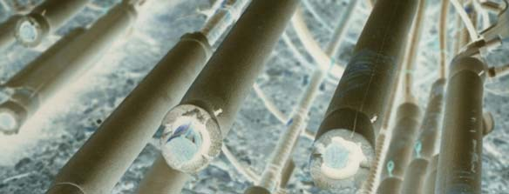
1. Reinforcement debonding, or any other items attached to the pile reinforcement, can only be placed in the pile to the same tolerances as the pile reinforcement. These tolerances are given in the ICE Specification for Piling and Embedded Retaining Walls 1996. Engineers/Specifiers should therefore specify the same tolerances for pile cut-off-level if such systems are to be used.

- Before specifying reinforcement debonding, or any other related systems, discussions must take place with the piling contractor in order to investigate the practicality of the proposed system for the chosen piling technique, pile size, the prevailing ground conditions. This technique is not universally applicable.
- Any system installed should be protected from damage, otherwise the system may lose all intended benefits. For example, the debonding of bars will not be effective if the bars are bent during or after installation.
- The lifting point for the removal of the concrete over the debonded length should be designed and specified by the main contractor following discussions with the piling contractor.

July 2005

