***Please insert your company logo here***

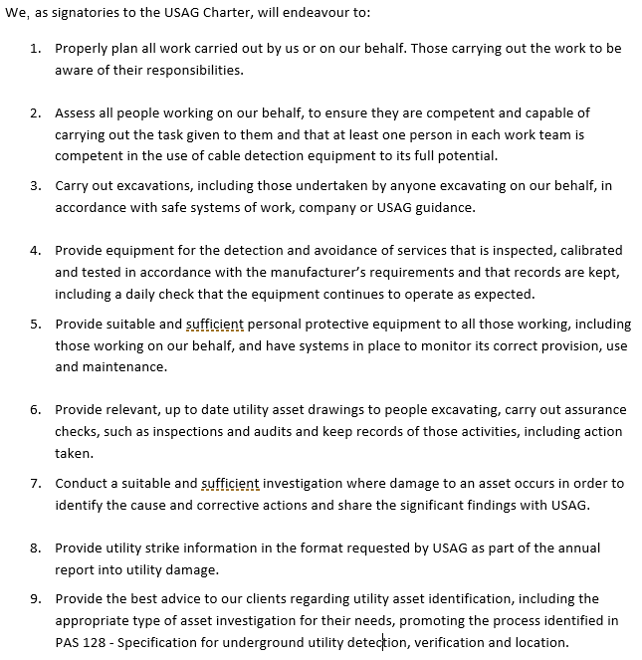

Signed:

Name of Company:

Date: