Eurocode 2 – Structural Capacity Check

BS EN 1992-1-1:2004 clause 3.1.6 outlines calculation of concrete compressive strength as follows:

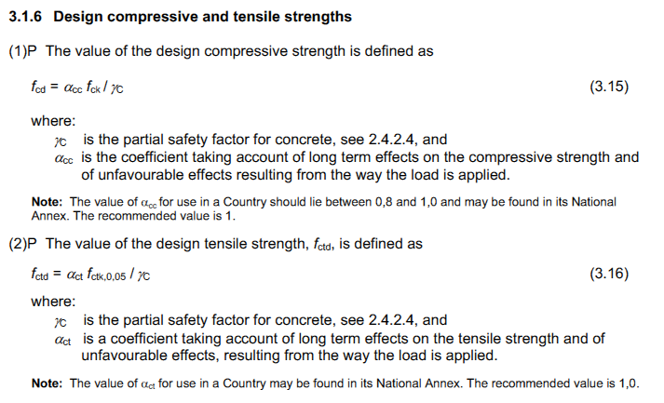

Where γ_{c} = 1.5 (for permanent and transient actions)
K_{f} = 1.1 (for cast in-situ piles without permanent casing)
α_{cc} = “should lie between 0.8 and 1.0 and may be found in its National Annex”. UK NA confirms “may be taken conservatively as 0.85 for all phenomena
α_{ct} = 1.0

Looking at a comparative case for a 600mm diameter pile constructed using C32/40N concrete, the following SLS capacities are calculated: BS8004 (1986) = 2,827kN
EC2 (α_{cc} =0.85) = 3,376kN (assuming 80/20 perm/var split)

The EC2 capacity with α_{cc} =0.85 equates to a 19% increase compared to BS8004 (1986), equivalent to approximately 0.3f_{cu}.

The Concrete Centre (in correspondence) point to clause 9.2.1.1(2) and conclude that unreinforced piles should be considered as plain concrete and designed in accordance with Section 12.

Section 9.2 is for beams, so not specific to piles however Section 9.8.5 Bored Piles does contain the following clause:

Under BS8004 (1986) the presence of reinforcement did not change the calculation of limiting compressive stress. It also noted that “the allowable compressive stress may be increased at the discretion of the engineer”.

BS EN 1992-1-1:2004 Section 12 – Plain and lightly reinforced concrete structures
Cl. 12.3.1

Note the recommended value of 0.8 within base code compared to α_{cc} and α_{ct} = 1.0. The UK NA states α_{cc,pl} = 0.6 and α_{ct,pl} = 0.8.

Looking at a comparative case for a 600mm diameter pile constructed using C32/40N concrete, the following are calculated: BS8004 (1986) = 2,827kN
EC2 (α_{cc} =0.6) = 2,386kN (assuming 80/20 perm/var split)

The EC2 capacity using α_{cc} =0.6 equates to a 16% decrease compared to BS8004 (1986), equivalent to approximately 0.2f_{cu}.

PD 6687-1:2010 discusses derivation of UK NA α_{cc} =0.85 however Section 12 is not considered.

Summary
Piles are generally reinforced over at least their upper portion of say 6m. Below this, dependant on the loading condition, ground conditions and piling technique the pile section may or may not be reinforced. It is common practice for CFA or small diameter rotary bearing piles to have unreinforced lengths of perhaps 70-80% of their total length.

Adopting the lower α_{cc} =0.6 value is onerous and would adversely affect design. It would also represent a retrograde step from historical practice within the UK. A reduction in load within the pile could be considered based upon the shaft friction mobilised at a certain depth within the pile, however this approach lacks certainty and is somewhat cumbersome.

The reference within EC2 to Section 12 in relation to pile design is not clear and no guidance is given to why these additional rules should apply. Justification for ignoring the requirements for plain concrete in relation to piles can be found in clause 12.1(2) as highlighted below.

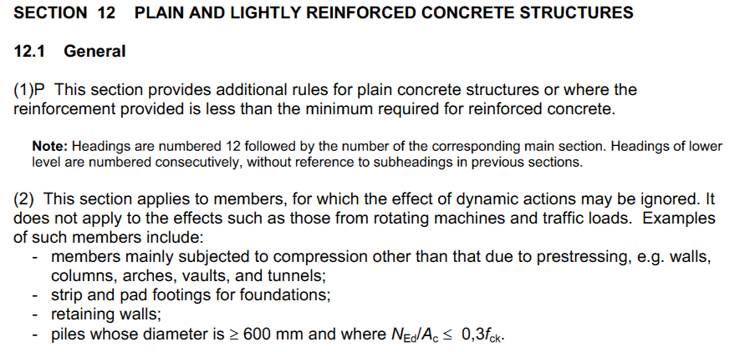

Current wording of FPS position paper is as follows:
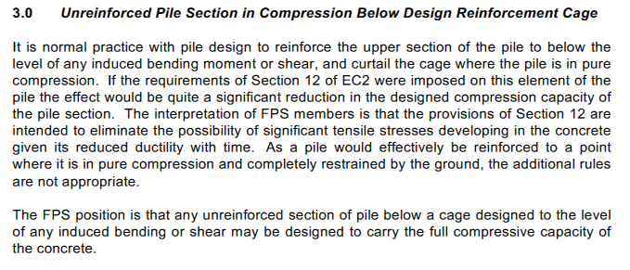

Suggested revised wording:
Within the UK it is normal practice with pile design to reinforce the upper section of the pile to below the level of any bending moment or shear. Below this level, where the pile is acting purely in compression, reinforcement is curtailed.

The requirements of Section 12 within EC2 would impose a significant reduction in the designed compression capacity of the pile. This approach is onerous and introduces additional conservatism when compared to historical UK practice. It is the interpretation of FPS members that as a pile would be designed to be reinforced to the point at which it is in pure compression and confined by the ground, the additional rules outlined within Section 12 are not appropriate [see clause 12.1(2)].

The FPS position is that any unreinforced section of pile below reinforcement designed to the level of any induced bending or shear may be designed to carry the full compressive capacity of the section in accordance with EC2 cl. 3.1.6.

